Release Assembly
TC Registration Site 2 Handle Validation Upgrade version 1.0

Deployment Guide

Revision History
Author | Revision Number | Date
leo_lol | 1.0 | 07/02/2012

Deployment Instructions 3
1. Organization of Submission 3
2. Application Setup 3
3. Database Setup 3
3.1 Please make sure your Informix is built from scripts whose revision number is greater or equal to 81598. Here is mine on VM: 3
4. Deployment Instructions 4
5. Starting 4
6. Verification 5
7. Resource Contact List 8

Deployment Instructions

Organization of Submission

The submission follows directory structure provided below:

docs

Contains this document which is the Deployment Guide.
web
Contains all created or updated files

DDL
Contains SQLs to execute.

Application Setup

The application is expected to be deployed to the following environment:

JRE 1.5
JBoss 4.0.2.GA
Informix DS 11.0

Database Setup

Please make sure your Informix is built from scripts whose revision number is greater or equal to 81598. Here is mine on VM:
/home/informix -> cd scripts/
/home/informix/scripts -> svn info
Path: .
URL: https://coder.topcoder.com/internal/database/scripts/trunk
Repository Root: https://coder.topcoder.com/internal
Repository UUID: cb5b18d2-80dd-4a81-9b1c-945e1ee644f9
Revision: 81598
Node Kind: directory
Schedule: normal
Last Changed Author: mashannon168
Last Changed Rev: 81596
Last Changed Date: 2012-07-10 16:50:35 -0400 (Tue, 10 Jul 2012)

Head revision should be fine
  - Verify commands/queries: “invalid_handle”, “invalid_handle_all” is present in informixoltp database.
- Connect to VM Informix instance via Server Studio.
- Query against Informixoltp using the following command:
select * from command where command_desc like 'invalid_handle%';
You should see:
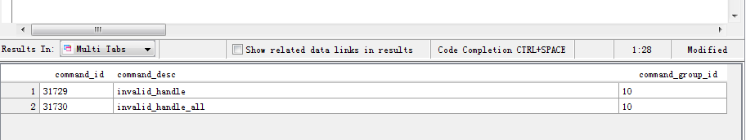

select * from query where name like 'invalid_handle%';
You should see:
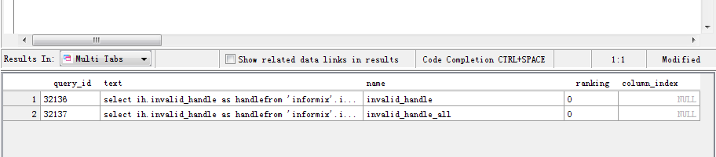
If the text column is null, you could update its content using the following text from SVN
invalid_handle, invalid_handle_all by way of query tool at http://tc.cloud.topcoder.com/query/query

  - Execute DDL/Update.sql and DDL/invalidHandles.sql.

Deployment Instructions

- Please make sure you are using the reg branch instead of trunk. This means if you execute “svn info” command at /mnt/shared/web, you should see:
[tc@ip-10-72-203-38:~/web] svn info
Path: .
URL: https://coder.topcoder.com/internal/web_module/branches/tc_reg_revamp
Repository Root: https://coder.topcoder.com/internal
Repository UUID: cb5b18d2-80dd-4a81-9b1c-945e1ee644f9
Revision: 81558
Node Kind: directory
Schedule: normal
Last Changed Author: mashannon168
Last Changed Rev: 81478
Last Changed Date: 2012-06-14 11:51:23 -0400 (Thu, 14 Jun 2012)
Make sure your VM is properly set, say you can “deploy” before making any changes.

- Check out the following branch https://coder.topcoder.com/internal/gd/trunk/website/tcdocs, and manually copy i/reg, css/reg and js/reg to corresponding locations of /mnt/apache/tcdocs on vm.

- Merge files from this submission/web to /home/tc/web

- Stop JBoss instance “jbb && ./kill.sh” and type y when prompting.

- Execute the “deploy” ant target of build_tc.xml, in terms of command, you could “ant –f build_tc.xml deploy”.

- Start JBoss instance, command on VM is : “jbb&&./start.sh&&tn”.

Starting
Please refer to section 4 to deploy and start.

Verification
- Make sure you have updated your hosts file as instructed http://www.topcoder.com/wiki/display/docs/VM+Image+2.5
- Go to http://tc.cloud.topcoder.com/reg. You should see something as below:
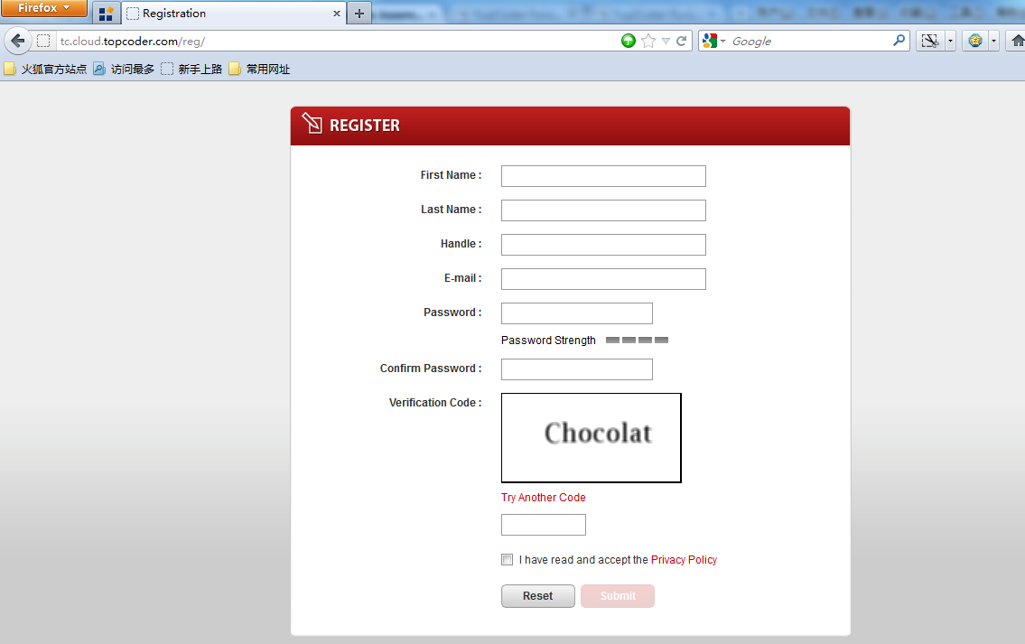
- Input some data, say try the illegal handle “11wh0re”:
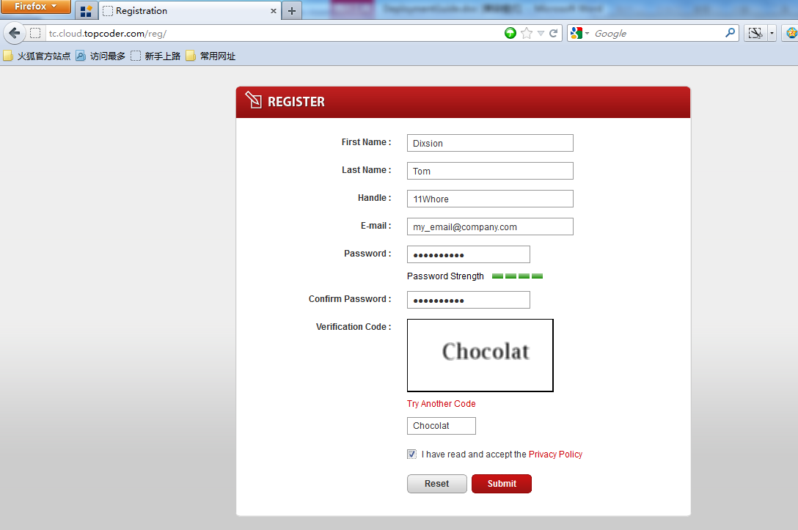
- Click submit, you should the error message as below:

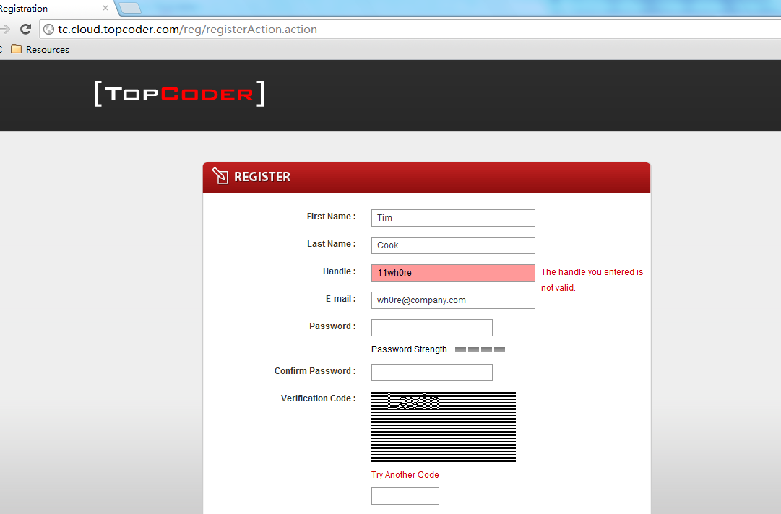

Register using “a55wipe”, you should see the following error:
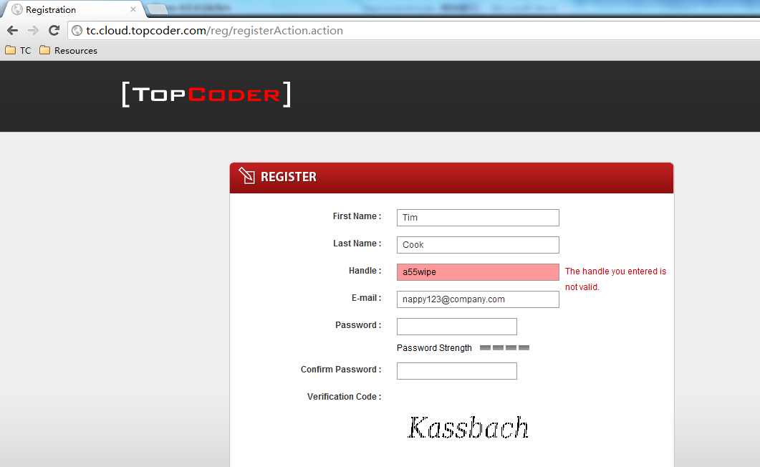

Append “s” to the invalid handle, i.e. “a55wipes” and retry, it’s shown like below:
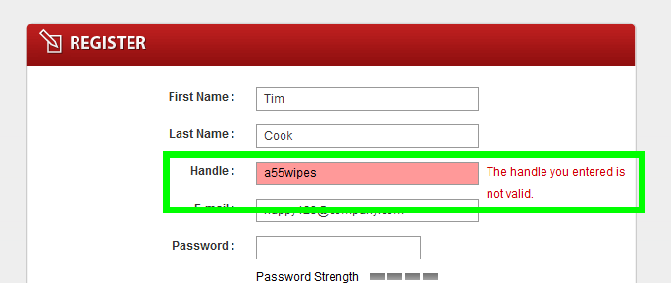

Prepend and append some digits, for example, “123a55wipe321”,
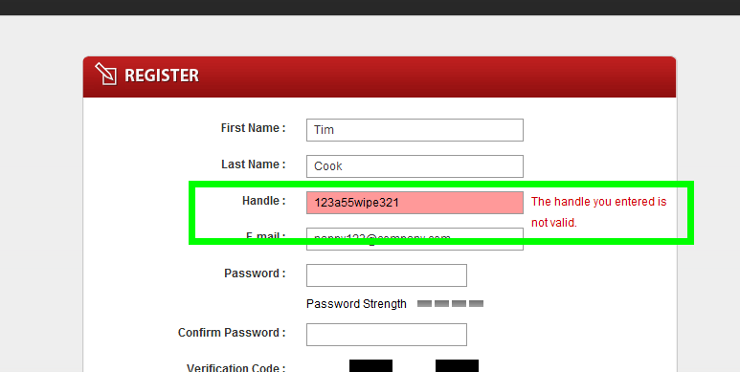

If you try to register a handle that already exists, you should see something like below:
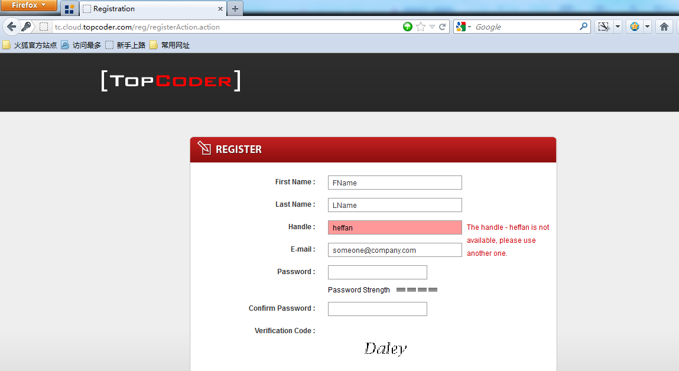

When input a really long handle to register: you should see the following error:
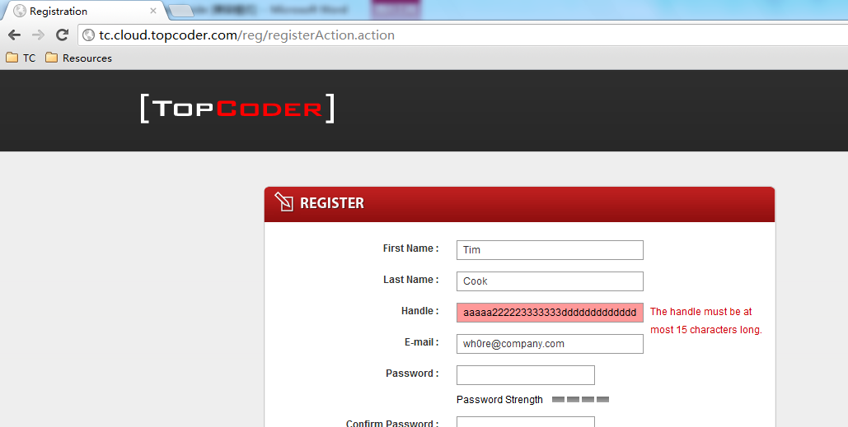

Trying to register a handle starting with admin, you would see the following error message:
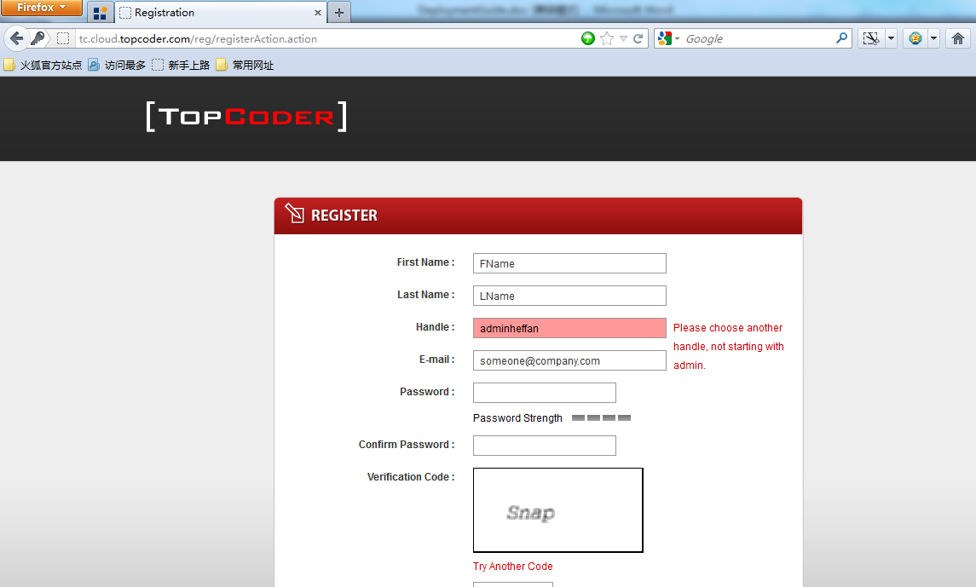

For the rest validation rules, please try out yourself.

Resource Contact List

Name | Resource Email
leo_lol | lizhanhui@gmail.com

